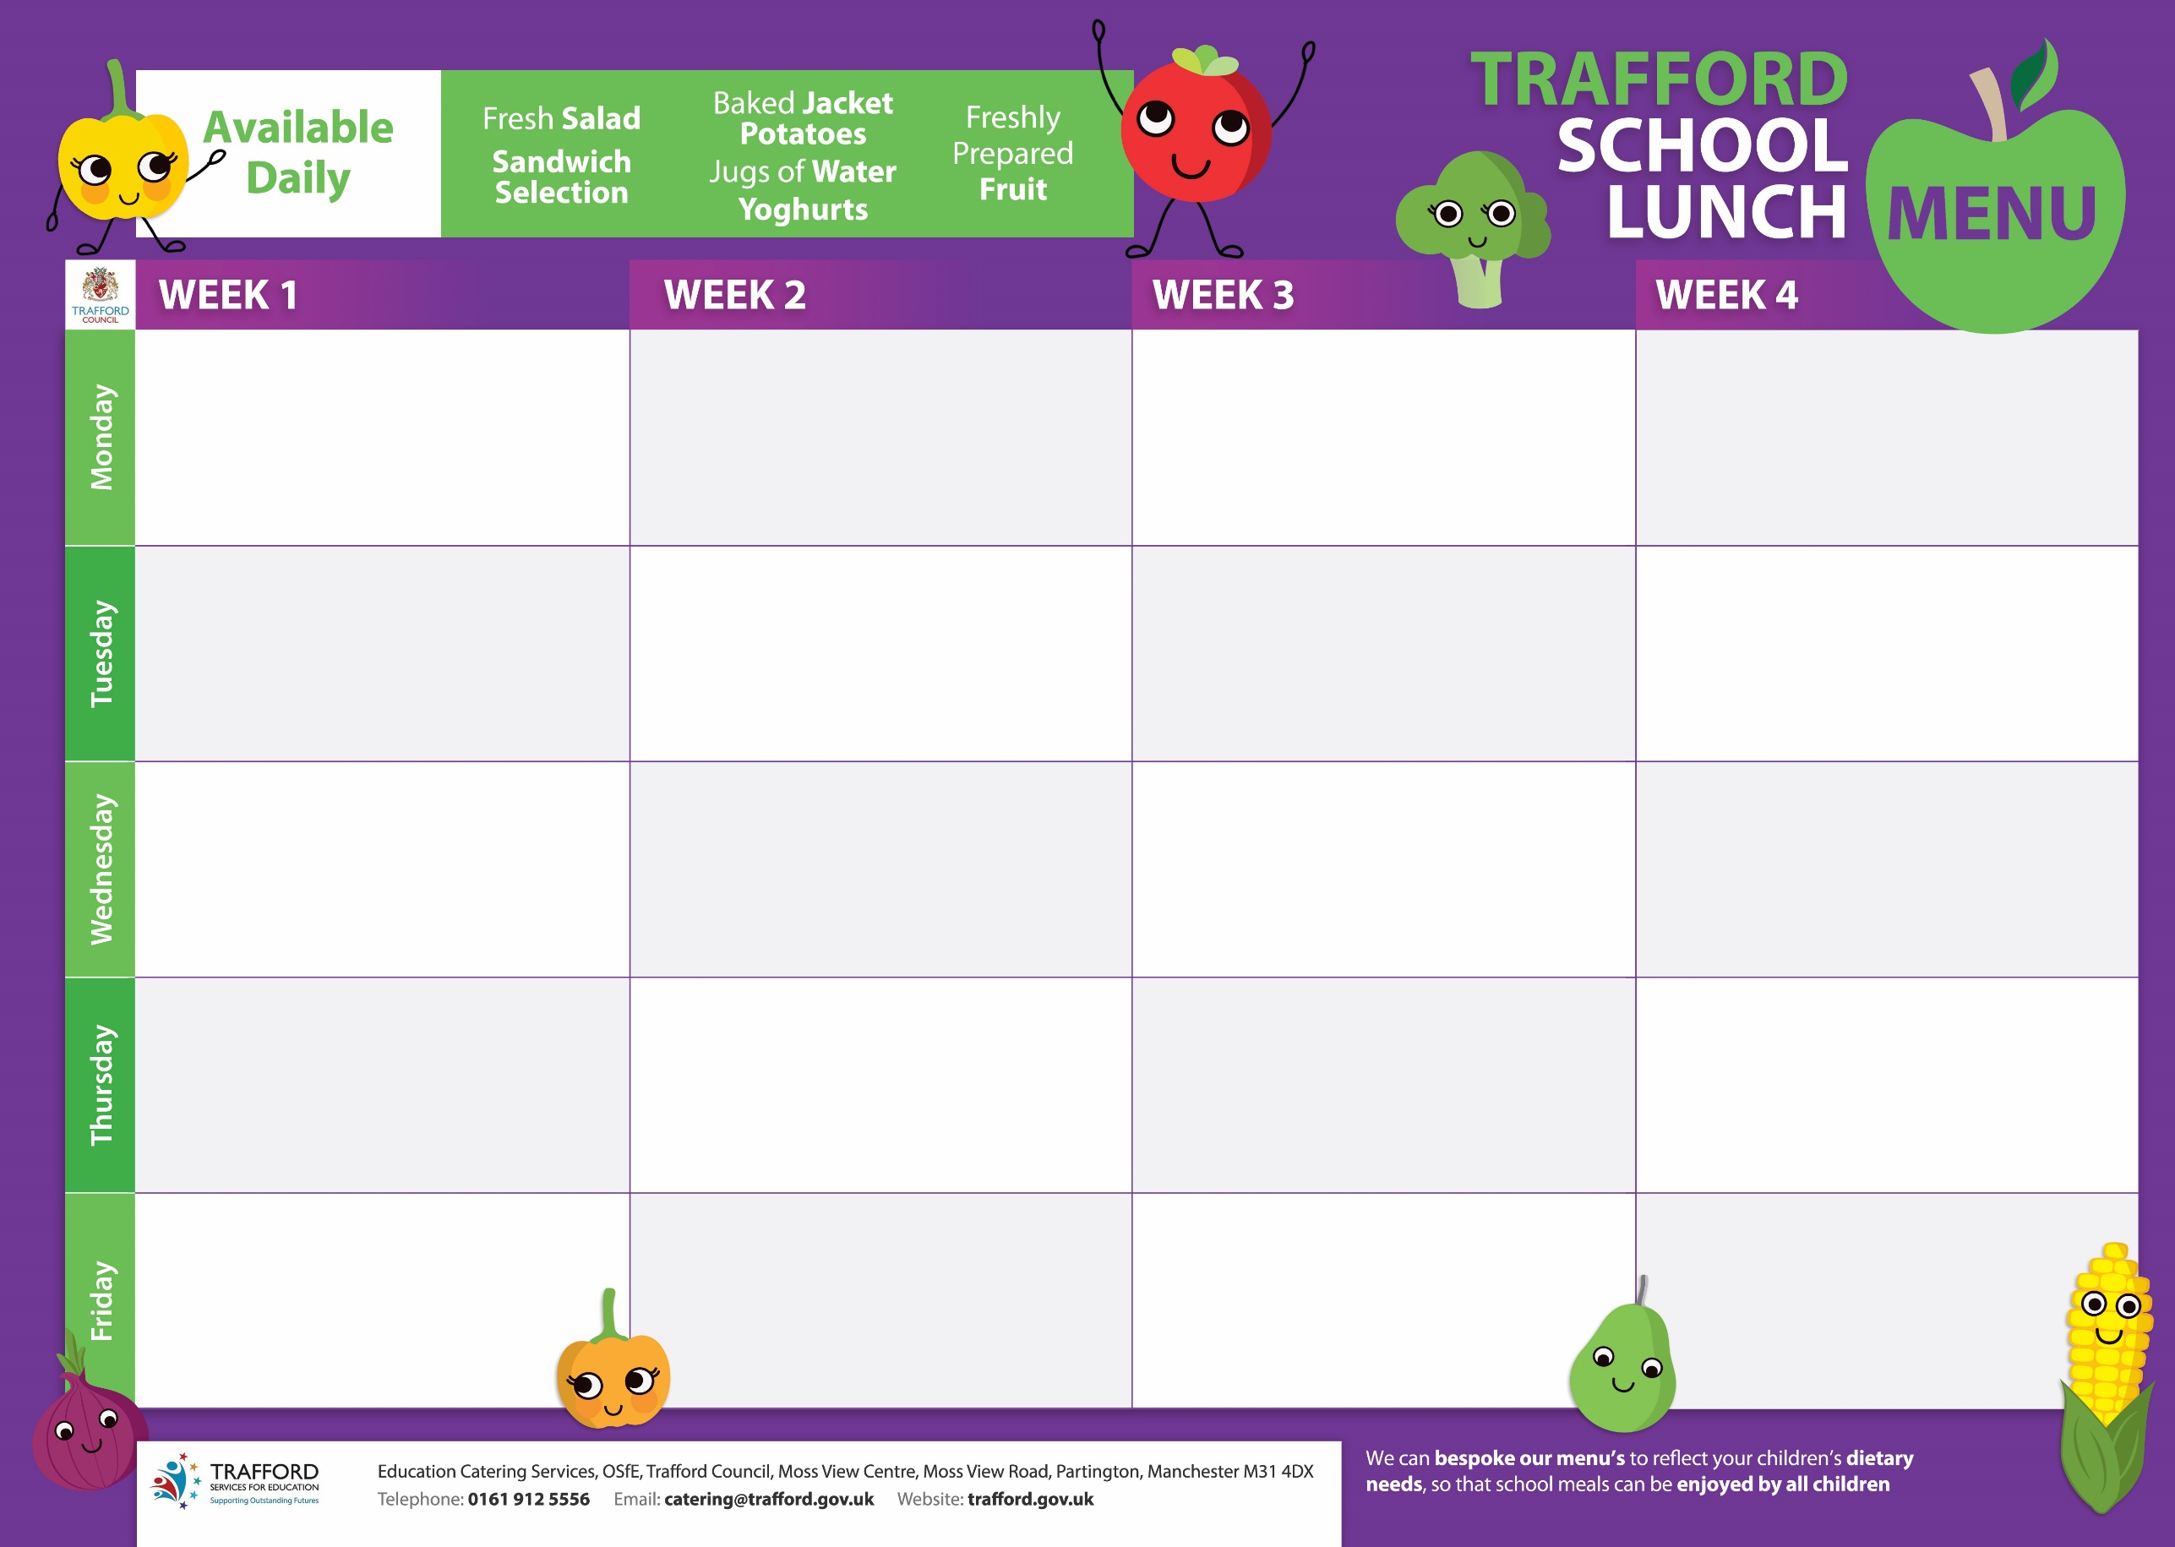

Beefburger on a Bun

Quorn Burger on a Bun

Diced Potatoes, Baked Beans, Sweetcorn

Jam Doughnuts

Omega 3 Fish Fingers

Chips, Rice, Peas, Diced Carrots

Ginger Cookies

Garlic &Herb chicken

Cheese Whirl

Noodles, Jkts, Green Beans, Sweetcorn

Fruity Chocolate Traybake

Roast Beef/Yorkshire Pudding

Cheese & Vegetable Quiche

Roast Potatoes, Carrots, Broccoli

Blueberry Muffins

Macaroni Cheese

Vegetable Sausages

Crusty Bread, Potato Wedges, Sweetcorn

Apple Crumble & Custard

Fish Fingers

Vegemince Bolognaise

Chips, Pasta, Mushy Peas, Carrots

Orange Cookies

Cajun Chicken

Vegetable Samosa

Herb Cous Cous, Sweetcorn, Peppers

Strawberry Ice Cream

Fish Fingers

Tomato Pasta

Oven chips, Baked Beans, peas

Banana & Sultana Loaf

Pizza

Veg Fingers

Diced Potatoes, Peas

Banana Muffins

Sausages Rolls

Vegetable Quorn Rolls

Sweetcorn, Baked Beans

Chocolate Shortbread

Chicken Korma Curry

Chickpea Korma Curry

Rice, Naan Bread, Mixed Vegetables

Lemon Drizzle Cake

Chilli Con Carne

BBQ Linguine

Rice, Garlic Bread, Sweetcorn

Chocolate Cake & Custard

Gammon Steak with pineapple

Roast Quorn Joint

New Potatoes, Sweetcorn

Pizzapple Sponge & Custard

Roast Turkey

Tomato & Cheese Pasta

Roast Potatoes, Diced Carrots, Peas

Flapjack

Roast Chicken

Quorn Roast

Roast Potatoes, Baton Carrots, Broccoli

Light & Fluffy Whip

Spaghetti Bolognaise

Garlic Bread, Spaghetti, Peas

Fruit in Jelly

Pork Sausages

Omelette

Creamed Potatoes, Baked Beans, Peas

Chocolate Crispies

Sausage Roll

Spaghetti Napolitana

Garlic Bread, Green Beans

Anzac Biscuit

Pizza

Tomato & Basil Pasta

Baked Beans, Diced Potatoes

Vanilla Ice cream

Turkey Meatballs in Gravy

Quorn Burger

Sauteed Potatoes, Baked Beans & Peas

Raspberry Ripple Ice Cream