Intent :
Our rationale for the Early Years Foundation Stage at Flixton Primary School.

At Flixton Primary School we recognise that the Early Years Foundation Stage is a crucial period of learning and development in every child’s life. We use developmentally appropriate practises, an informed knowledge of the needs of each child and an understanding of social, cultural and linguistic contexts in which children learn in order to support each and every child’s physical well-being and motor development, social and emotional development and language and cognitive abilities during this crucial phase of a child’s life.
We recognise that a well-planned, play based approach is the best for our children in a nurturing and supportive environment.

“Every child deserves the best possible start in life and the support that enables them to fulfil their potential. Children develop quickly in the early years and a child’s experiences between birth and age five have a major impact on their future life chances. A secure, safe and happy childhood is important in its own right. Good parenting and high-quality early learning together provide the foundation children need to make the most of their abilities and talents as they grow up.” Statutory Framework for the Early Years Foundation Stage.

At Flixton Primary School we have 4 key principles that underpin all of our EYFS practice.

- All of our children are unique children who are constantly learning, can be resilient, capable and confident and self-assured.
- Our children learn to be strong and independent learners through quality relationships.
- Our children learn and develop well through enabling environments that respond to their needs.
- All of our children learn and develop in different ways and at different rates. Our EYFS allows our all of our children to learn and make progress.

Excellence in Early Years at Flixton Primary School is demonstrated by:

A  We allow children time and space to follow their interests and become deeply involved in their learning. | E  We have environments that are emotionally safe and physically rich, indoor and out. |  | I  We have quality interactions with children by having staff who tune into and help extend children’s learning.
O  Our observation based assessment helps us to gain knowledge about individual children from a range of sources, helping us to know their strengths, needs, passions and interests. |  | U  Our staff have good understanding of child development, the characteristics of effective learning and what research tells us about how children learn best.
A firm foundation of strong positive relationships with children, parents and carers and other adults involved in children’s learning and development.
Implementation:

The key elements outlined in the excellence statement underpin all of our EYFS provision. Alongside these key elements are the following:

Areas of learning

Across our Early Years Foundation Stage, children work towards the Early Learning Goals across the seven areas of learning.

The three prime areas are crucial in the children’s learning and in developing curiosity, an enthusiasm for learning, for forming relationships and developing positive learning behaviours that start their school life.

Communication and language.
We give our children opportunities to experience a language rich environment, to develop their own confidence in expressing themselves and opportunities to speak and listen in a variety of different ways.

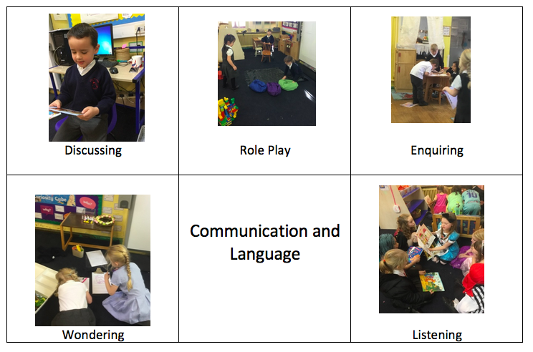

Physical development
We provide opportunities for our children to be active and interactive, to develop their control, co-ordination and movement. We support our children in understanding the importance of physical activity and how to make healthy food choices. We prepare our children for the skills they will need to be able to write. This year we have been using Squiggle While you Wiggle to support the development of gross and fine motor skills as a result of the lockdowns due to Covid.

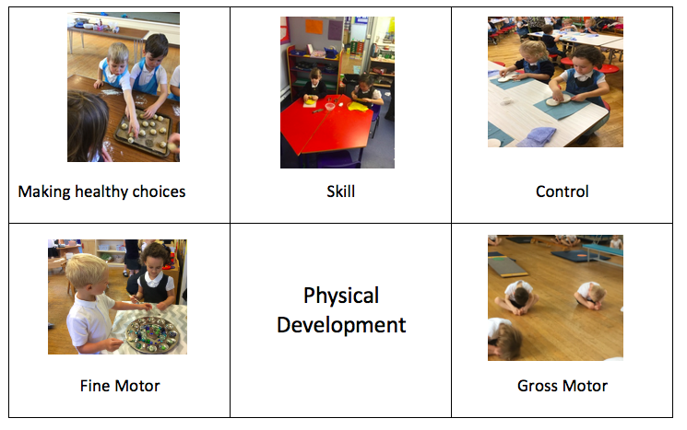

Personal, social and emotional development
We provide opportunities and encourage children to develop a positive sense of themselves and their friends, to develop social skills and to learn how to manage their feelings and behaviour. We give them chance to develop their confidence in their own abilities through positive relationships and quality interactions with their peers and staff.

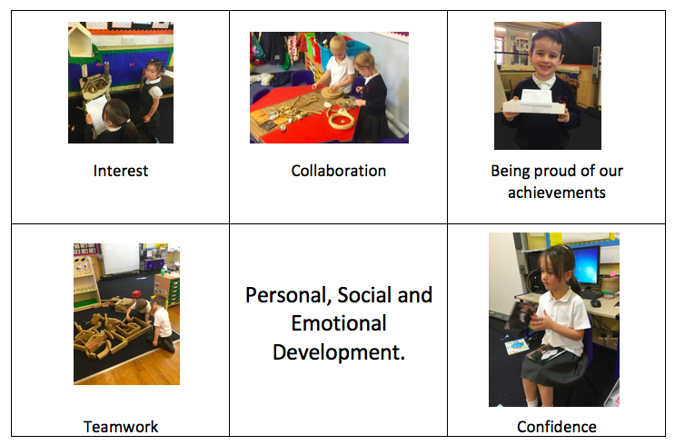

The specific areas allow opportunities for skills to be strengthened, practised and applied in children’s own learning.

Literacy
We allow our children to develop their knowledge of letters and sounds to enable them to begin to read and write. We provide a wide range of reading and writing materials to support their interests. We encourage children to read and write for a purpose to fuel their love for learning.

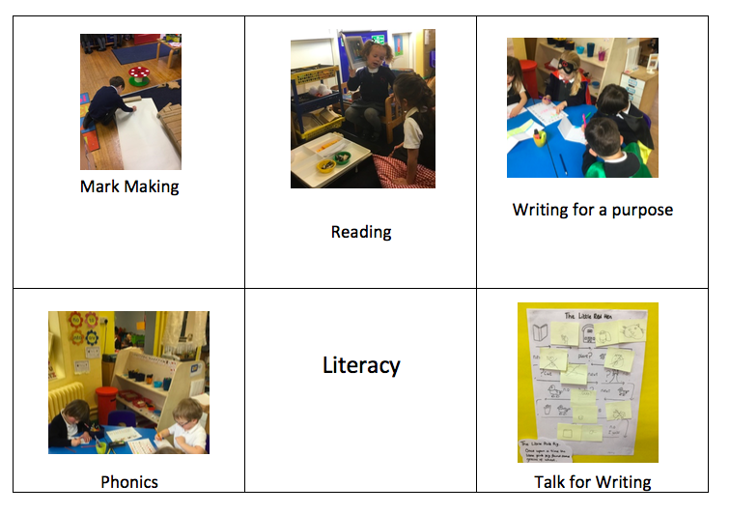

Maths
In our early years you will see opportunities for children to count, exploring and ordering numbers in their play. Continuous provision will provide opportunities for children to add and subtract in purposeful situations. Children are challenged to solve problems in their learning and to use appropriate language to describe what they have found out. Through their explorations in play they find out about shapes, space, measures and time.

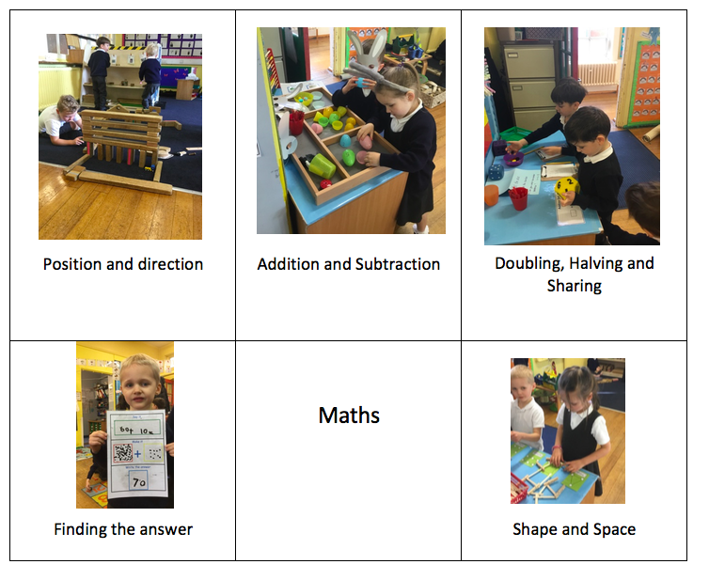

Understanding the world
We provide opportunities for children to explore, observe, and find out about people and places, technology and the environment therefore making sense of their physical environment and their community.

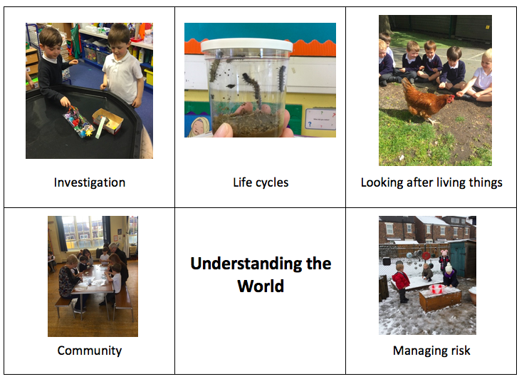

Expressive arts and design
Through expressive arts and design, we enable children to explore and use a variety of media and materials as well as providing opportunities for them to share their thoughts, feelings and ideas. We offer a wealth of opportunities in art, music, role play and dance and design and technology to support this area of development.

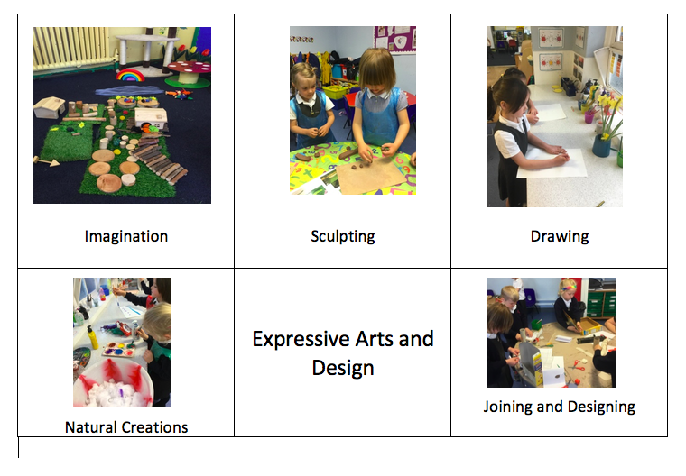Area of continuous provision

Areas of Continuous Provision are used throughout the early years environment and are adapted according to the needs and interests of the children. Both indoors and outdoors, areas of provision are well planned with good quality, open-ended resources that are utilised in order to enhance children’s learning experiences.
In both Reception and Nursery children have access to uninterrupted periods of COOL time (Choose our own learning), therefore enabling them to practise and refine their skills, explore the open-ended resources and challenge their own learning.

Visual timetables support all children’s learning and are used throughout the learning environment.

Nursery- Daily Routine
In Nursery the children begin the day with a period of COOL time and then a short carpet session. The children then access both indoor and outdoor provision and focus tasks may take place in this time. Carpet times are built upon during the year and will focus on different areas of learning according to the children’s needs and interests. Phases is embedded throughout the provision and may take the form of a daily small group, a large group or 1:1 activities.

Reception - daily routine
At the beginning of the year children are asked to self-register when they come into school. As the year progresses children are presented with a ‘morning challenge’ to ensure they are settled and ready to learn. Whole class phonics is taught daily, first thing and is a discreet lesson. This is followed by Cool time in continuous provision areas. A playtime has been incorporated to allow for a quality reading time each day. Opportunities for outdoor learning are utilised during the morning and the afternoon. Talk for writing or an English focus is taught in the session before lunchtime and a guided writing group will take place daily. In the afternoon, a maths focus is taught and again, focus maths groups are taught throughout the week. The end of the day carpet time focusses on a different area of learning which may include music, PSHE, RE or other areas of learning. Opportunities for stories, rhymes and songs are utilised daily.

Impact statement

The impact of this policy on outcomes for children is measured against our Excellence Statements for Early Years.
The Early Years leader monitors the impact of this policy through:
Learning journey scrutiny
Pupil voice/survey
Data analysis
Teacher interview/survey
Leadership team monitoring is also fed to the Early Years lead.

